|  |
| --- |
| **CSE3003-Operating Systems-Laboratory-Practical Exercises** |

Date:

**Ex.No:1.b) Study of UNIX Commands.**

**Write the Syntax, description, executed Output screenshot of any 25 UNIX commands?**

e.g. format:

**1) Count word in a File:**

Description: If you want to find out how many times a single word has appeared in a file, use the following command:

Syntax: grep -c <word-to-count> <filename>

Output Screenshot for **Count word in a File:**

:[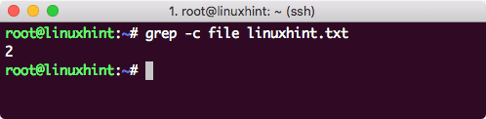](https://linuxhint.com/wp-content/uploads/2018/05/word-count.png)

**Sample Commands:**

cat, cd, cp, chmod, df, less, ls, mkdir, more, mv, pwd, rmdir, rm, man, uname, who, ps, vi, cal, date, echo, bc, grep.

Online Linux URL:

https://bellard.org/jslinux/vm.html?cpu=riscv64&url=fedora33-riscv.cfg&mem=256

|  |
| --- |
| **Name of the Student: Reg. No** |